**What is an Apple?**

An apple is**a round, edible fruit** produced by**an apple tree.** Apple trees are cultivated worldwide and are the most widely grown species in the genus Malus. Apples contain key nutrients, including fiber and antioxidants. They may offer health benefits, including lowering blood sugar levels and benefitting heart health. Apples are among the world’s most popular fruits. Apples are high in fiber, vitamin C, and various antioxidants. They are also very filling, considering their low-calorie count. Usually eaten raw, apples can also be used in various recipes, juices, and drinks. Various types abound, with a variety of colors and sizes. Apples are mainly composed of carbs and water. They’re rich in simple sugars, such as fructose, sucrose, and glucose. Despite their high carb and sugar contents, their glycemic index is low, ranging 29-44. The glycemic index is a measure of how food affects the rise in blood sugar levels after eating. Low values are associated with various health benefits. Due to their high fiber and polyphenol counts, fruits often have a low glycemic index score. Apples are very rich in fiber. A portion of their fiber comes from insoluble and soluble fibers called pectin. Soluble fiber is associated with numerous health benefits, partly because it feeds the friendly bacteria in your gut. Fiber may also help improve fullness and cause weight loss while lowering blood sugar levels and boosting digestive function. For the reason, this fruit might be a beneficial dessert or addition to a meal to add sweetness.

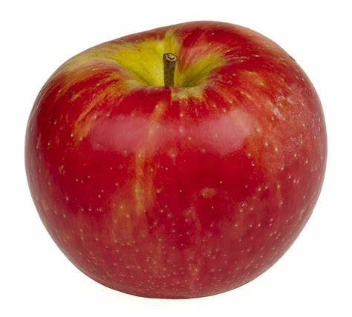 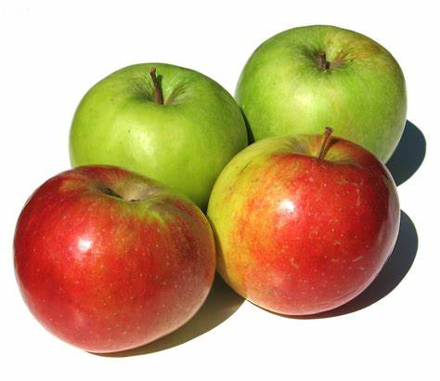

**What is Garlic?**

Garlic has some real health benefits, such as protection against the common cold and the ability to help lower blood pressure and cholesterol levels. Garlic is a plant in the Allium family. It’s closely related to onions, shallots, and leeks. Each segment of a garlic bulb is called a clove. There are about 10–20 cloves in a single bulb, give or take. Garlic grows in many parts of the world and is a popular ingredient in cooking due to its strong smell and delicious taste. Scientists now know that most of garlic’s health benefits are due to the formation of sulfur compounds when you chop, crush, or chew a garlic clove. The sulfur compounds from garlic enter your body from the digestive tract. They then travel all over your body, exerting strong biological effects. The potential effects of garlic on longevity are basically impossible to prove in humans. But given the beneficial effects on important risk factors like blood pressure, it makes sense that garlic could help you live longer. At high doses, the sulfur compounds in garlic have been shown to protect against organ damage from heavy metal toxicity. Allicin in garlic can help reduce levels of lead in your blood and vital organs. Garlic is very easy to include in your current diet. It complements most savory dishes, particularly soups and sauces. The strong taste of garlic can also add a punch to otherwise bland recipes. Garlic comes in several forms, from whole cloves and smooth pastes to powders and supplements like garlic extract and garlic oil. A common way to use garlic is to press a few cloves of fresh garlic with a garlic press, then mix it with extra virgin olive oil and a bit of salt. This works as a very simple and nutritious salad dressing.

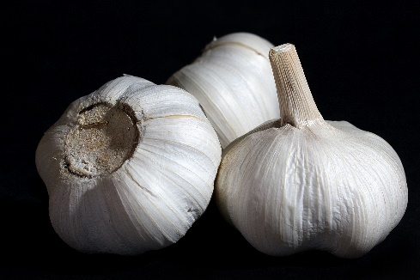 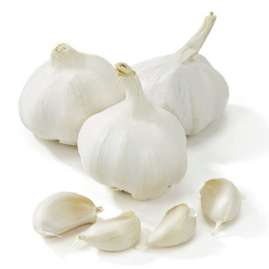

What is Quinoa?

Quinoa is a whole grain packed with nutrients, fiber, protein, and plant compounds. It has many health benefits and is an easy way to add variety to your diet. Quinoa is an ancient South American grain that was largely ignored for centuries. Interestingly, it was only recently noticed by the rest of the world and hailed as a “superfood” due to its high nutritional content. It is now considered a specialty food by foodies and the health conscious. This article looks at what quinoa is, where it comes from and why it’s so good for you. Since then, it has experienced a huge surge in popularity because of its high nutrient content and health benefits. It is also easy to grow in a range of conditions. In fact, the year 2013 was named “The International Year of Quinoa” by the UN because of its valuable qualities and potential to fight world hunger. Quinoa is also popular because it’s a gluten-free grain. This means people with celiac disease, wheat allergies or those who avoid gluten can consume it. However, the most widely grown types are red, black, and white. There is also a tricolor variety, which is a mixture of all three. Quinoa can also be rolled into flakes or ground into flour, which can then be used for cooking and baking. White quinoa is the most consumed variety and is what you’ll usually find at the store. Interestingly, the different types also have varying nutrient contents. Red and black quinoa also have nearly twice the vitamin E content of white quinoa. The same study analyzed the antioxidant content of each type and found that the darker the color, the higher the antioxidant capacity.

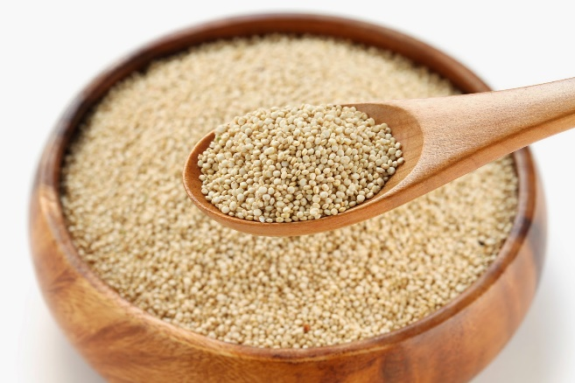 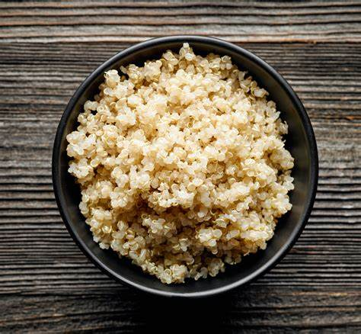

What Is Cinnamon?

Cinnamon is a spice made from certain types of trees. Extracts from the bark as well as leaves, flowers, fruits, and roots of the cinnamon tree have been used in traditional medicine around the world for thousands of years. It’s used in cooking and baking and is added to many foods. There are four major types of cinnamon. Darker-colored cassia cinnamon is the one most sold in the United States. It’s grown in southeastern Asia. Ceylon cinnamon, also known as true cinnamon, is frequently used in other countries. The cinnamon you buy at the store could be one of the two main types, Ceylon or cassia, or a mixture of both. Ceylon is easier to grind, but it may not have the same health benefits. Cinnamon does have antioxidant, antibiotic, and anti-inflammatory properties, but for now, there aren’t enough studies to prove it works that well in people. One of the most important active ingredients in cinnamon is cinnamaldehyde. It’s used in flavorings and fragrances. It may be responsible for some of cinnamon’s possible health benefits. Cinnamon doesn't just spice up the flavor of your food and drinks. It has many health benefits, too. Some research shows cinnamon may be good for people with diabetes. A review of 18 studies suggests that cinnamon might lower blood sugar. But it didn’t affect hemoglobin A1c, which is a sign of blood sugar levels over time. It may also lower cholesterol in people with diabetes. Many of the studies don’t say what type of cinnamon was used or have other problems that make their findings uncertain. One review suggests the benefits of cinnamon for weight loss and obesity. It’s sometimes used for irritable bowel syndrome or other stomach or intestinal problems. But it isn’t clear that it works.

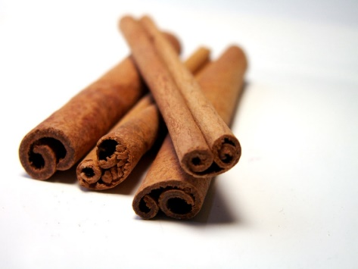 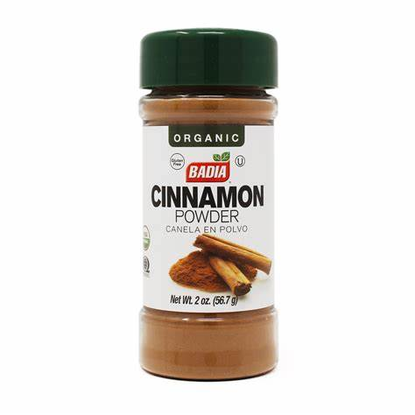

What is Water?

Drinking water has numerous benefits. Water is crucial for many bodily functions, such as lubricating the joints, delivering oxygen throughout the body, preventing kidney damage, and more. Around 60 percent of the body is made up of water, and around 71 percent of the planet’s surface is covered by water. Perhaps it is the ubiquitous nature of water that means drinking enough each day is not at the top of many people’s lists of priorities. Cartilage, found in joints and the disks of the spine, contains around 80 percent water. Long-term dehydration can reduce the joints’ shock-absorbing ability, leading to joint pain. Saliva helps us digest our food and keeps the mouth, nose, and eyes moist. This prevents friction and damage. Drinking water also keeps the mouth clean. Consumed instead of sweetened beverages, it can also reduce tooth decay. Blood is more than 90 percent water, and blood carries oxygen to different parts of the body. With dehydration, the skin can become more vulnerable to skin disorders and premature wrinkling. Dehydration can affect brain structure and function. It is also involved in the production of hormones and neurotransmitters. Prolonged dehydration can lead to problems with thinking and reasoning. Some scientists have proposed that consuming more water might enhance performance during strenuous activity. More research is needed to confirm this, but one review found that dehydration reduces performance in activities lasting longer than 30 minutes. Water may also help with weight loss if it is consumed instead of sweetened juices and sodas. “Preloading” with water before meals can help prevent overeating by creating a sense of fullness.

 